**The Fundamentals of InfoSec: Protecting Your Digital Assets Like A Pro**

“Information wants to be free”, they said. So do hackers, but with your credit card numbers

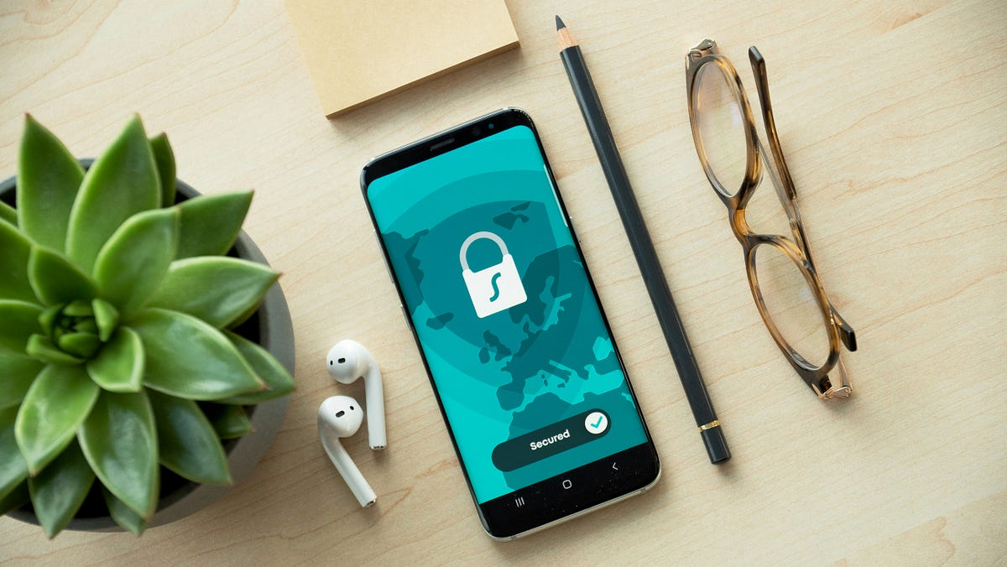Photo by [Dan Nelson](https://unsplash.com/@danny144?utm_source=medium&utm_medium=referral) on [Unsplash](https://unsplash.com?utm_source=medium&utm_medium=referral" \t "_blank)

Free Version for Non-Members: Here

**What is InfoSec, and Why You Should Care?**

If you think InfoSec is all about the hacker in the hoodie, let me be frank, it’s not. You may have been watching too many movies, or worse, the movies show only these aspects (It’s not your fault tbh).

Information Security (lovingly known as InfoSec) is the practice of protecting data. It includes securing your emails, keeping passwords away from digital pickpockets, and make sure your company’s “SecretSauceRecipe.docx” doesn't end up on a Russian Telegram Channel.

[Image](https://media0.giphy.com/media/v1.Y2lkPTc5MGI3NjExeXlzc3Fqd2FrMWY0Y3E2Y2FtMnQ3ZW5ycThoYm44aG42bXBvdDh4YSZlcD12MV9pbnRlcm5hbF9naWZfYnlfaWQmY3Q9Zw/NdKVEei95yvIY/giphy.gif) extracted from [GIPHY](https://giphy.com/)

At its core, InfoSec is mainly about three things:

* Preventing unauthorized access (aka ***Confidentiality***)
* Preserving data integrity (aka ***Integrity***)
* Ensuring services and data are available when needed (aka ***Availability***)

Simple? **Yes**

Boring? **Probably**

Essential? **Absolutely**

**Data Comes in Three Flavors (and Hackers want them all)**

Let’s clear the myth. Is Data only limited to your PDFs, your spreadsheets? Absolutely not.

Data is a shape-changer and lives in three forms:

1. **Data at Rest**: Stored in databases, hard drives, cloud storage, etc. Think of it as your digital closet. Organized or messy, it is still yours.
2. **Data in Transit**: Zipping through networks, like emails, messages, or file transfers. It is basically your data commuting, vulnerable to interception.
3. **Data in Use**: Actively being read or processed by a system. Like when you are filling a form online, and someone is shoulder surfing behind you (digitally or physically)

InfoSec’s job? It is to protect data in all of these stages.

Encrypt it while sitting (at rest). Guard it while it’s moving (in transit). And monitor it while it’s doing its thing (in use).

**Meet the InfoSec CIA**

We are talking about the core, foundational and the most basic concept of cybersecurity, the CIA triad (The three core principles of Information Security).

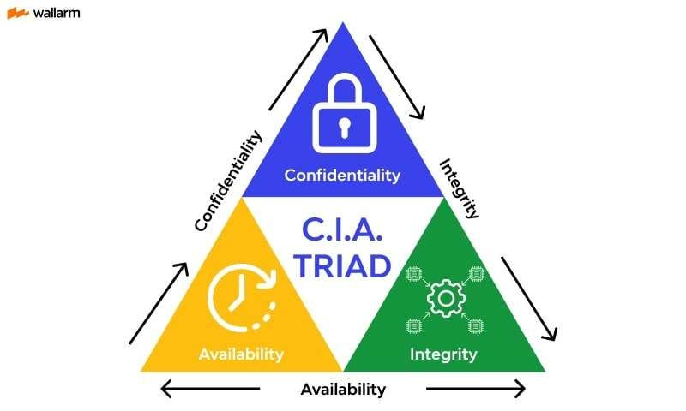[image](https://assets-global.website-files.com/5ff66329429d880392f6cba2/63fdd44daa2d3e1f527b40e7_CIA%20Triad.jpeg) extracted from [wallarm](https://www.wallarm.com/what/cia-triad-definition" \t "_blank)

* **Confidentiality**

Only the right people should access the data.

Like your weird poetry from 2010? That should stay between you and your therapist.

***Mechanisms***: Encryption, access control, two-factor authentication

* **Integrity**

The data should stay accurate and unaltered.

If your bank account suddenly shows an extra zero and it’s not payday, that’s probably a problem (or a very generous hacker).

***Mechanisms***: Checksums, hashing, digital signatures, version control

* **Availability**

You need your data and systems when you need them.

Imagine your online class crashing 30 seconds before you hit “*Submit Assignment*.” Now imagine that, but it’s an ER doctor trying to access a patient’s medical record.

***Mechanisms***: Redundancy, failovers, DDoS protection, backups

These three aren’t optional. Take away one and your security strategy collapses like a Jenga tower during an earthquake.

**Bonus Round: Other Security Principles You Should Pretend to Know**

[image](https://media0.giphy.com/media/v1.Y2lkPTc5MGI3NjExZnIzZzUyeG5hbjdtMDc4MHRseDJhcjE0MGhuZHF3ZndnamN6ZG02aCZlcD12MV9pbnRlcm5hbF9naWZfYnlfaWQmY3Q9Zw/l4FGzTRVr14I4Ja00/giphy.gif) extracted from [GIPHY](https://giphy.com/)

Sure, CIA gets all the fame, but there are other players in the InfoSec game. Let’s give them some credit and a bit of spotlight:

* **Non-Repudiation**

“*Wasn’t me*,” says the attacker. Too bad!

Non-repudiation ensures that once someone does something (like signs a document or sends a transaction), **they cannot deny it later**.

***Tools***: Digital signatures, audit logs

* **Accountability**

Every action should be traceable to a specific user or process. If something goes boom, you should know who pressed the big red button.

***Tools***: Logs, monitoring, identity management

* **Authentication & Authorization**

1. Authentication: Proving who you are (passwords, biometrics, tokens)
2. Authorization: Proving what you’re allowed to do (“Sorry, DarKVoicE. You don’t have access to delete the production database.”)

Together, they make sure the right people are doing the right things, in the right way, for the right reasons.

**Okay, But Why Does it Matter?**

Let’s get real: **everything is digital now**. Your medical history? Online. Your food orders? Online. Your private DMs complaining about your life issues? Definitely online.

Hackers don’t need to physically break into your home anymore. They just need you to:

* Click the wrong link
* Reuse a dumb password (Password123, 123, 12345)
* Ignore the system update way too many times

**InfoSec is your digital body armor.**  
And in today’s world, not wearing it is like walking into a sword fight in a bathrobe.

[image](https://media0.giphy.com/media/v1.Y2lkPTc5MGI3NjExeDV3dGtqOG50c2ZtMHY2NnZ5MGVzOGw1bXlhc3R5ZTBwY2p6c2ZibCZlcD12MV9pbnRlcm5hbF9naWZfYnlfaWQmY3Q9Zw/xUOwG8rJpsyDT3GjoA/giphy.gif) extracted from [GIPHY](https://giphy.com/)

**How InfoSec is Actually Implemented**

Behind the buzzwords and acronyms is a lot of stuff being actually done:

**Risk Management**

Assess what you care about, what can go wrong, and how badly. Then fix the worst risks first.  
Basically: Prioritize. Or be surprised.

**Security Controls**

* **Preventive**: Firewalls, antivirus, access restrictions
* **Detective**: IDS/IPS, monitoring, logs
* **Corrective**: Patching, backups, restoring services

These are like guards, alarms, and insurance policy for your castle

**Security Frameworks**

Because doing things randomly isn’t very secure.

* **ISO 27001**: The gold standard
* **NIST CSF**: A very American take on doing things properly
* **CIS Controls**: “Just tell me what buttons to press” for smaller orgs

These frameworks tell companies how to get their InfoSec act together without reinventing the wheel (or accidentally securing the wrong thing).

**The Threats You are Up Against**

[image](https://media3.giphy.com/media/v1.Y2lkPTc5MGI3NjExazEzZHY5eTM3MjZncHZnaHJ2NTFlbjdwcGJsaGN4Z2lhd2R0Mm55eiZlcD12MV9pbnRlcm5hbF9naWZfYnlfaWQmY3Q9Zw/l2SqbwVXdTR352vN6/giphy.gif) extracted from [GIPHY](https://giphy.com/)

If this was a movie, here is the list of the villains:

* **Hackers**: Script kiddies to cybercrime cartels
* **Insiders**: Angry employees or careless interns
* **Nation-states**: Because sometimes international espionage *is* personal
* **Natural Disasters**: Earthquakes don’t care about your uptime
* **You**: Yes, human error is still the biggest security risk

InfoSec isn’t about eliminating all threats, rather **it’s about being ready when (not if) something goes wrong**.

**Wrapping Up**

So here we are.  
InfoSec isn’t just about fancy tech, firewalls, or blinking dashboards. It’s about **understanding your digital risks** and **doing something about them** before your boss, your company, or your mom’s Facebook gets hacked.

And the best part?  
You don’t have to be a genius to start. You just need to **care enough to question**, **learn enough to act**, and **update your software like your life depends on it** (because sometimes… it does).

**Enjoyed the read?**  
Smash the follow button, drop a comment, and share this with someone who still thinks “password” is a good password.

If you enjoyed the reading, kindly subscribe to my page: [Here](https://medium.com/@Ethical_DarKVoicE/subscribe)

More chaos, hacks, and knowledge coming soon. Stay safe, stay paranoid.